Final Website Plan

Purpose Statement:

Crazy Haitian website will serve as an online platform for linking clients to the restaurant information and services.

Goals:

1. Create an organized space to view menus, see the calendar, apply to work at the restaurant, contact the restaurant, and view staff.
2. Increase traffic by 5% per month for the first 5 months of website launch.
3. Establish online shop for delivery and catering orders, merchandise, or other services.

Target Audience: Average Age/Range: 15-any  
Education level: N/A  
Median income:35,000  
Race: N/A  
Ethnicity: N/A  
Gender: N/A  
Primary spoken language: English  
Unifying characteristics: café-goers and coffee enthusiasts

Colors:

Header 1 – BF7432 Burn mango orange. This choice was because it’s a good contrast to the dark brown used in the rest of the café and because it gives a relaxed but sophisticated feeling. More of a neutral or cool color.

Header 2: 989017 Mustard yellow. This was chosen because it complements the main header as well as giving the banner a bit of an exotic feeling without detracting from the overall atmosphere.

Main site: mostly dark browns because it reflects the interior of the café and is an appropriate backdrop for the rest of the website. The buttons are white letters on grey because it makes them obvious without drawing too much attention to them.

Typography:

Header 1 is in Tahoma because it’s a sophisticated and easy to read font and it matches the style of the rest of the café. I also like that it allows for some flexibility in color choice and whether it’s bold or underlined. It looks iconic and stands out just enough from the rest of the website.

Header 2 is in courier new because it compliments header 1 really well and because it looks exactly how the words translate. Repoze Detant means “relax and pass time” in Haitian Creole and the font/color carry that ascetic well.

The rest of the words are in ariel or courier new depending on how much I wanted them to stand out. The menu items are in ariel because it’s clear and easy to see.

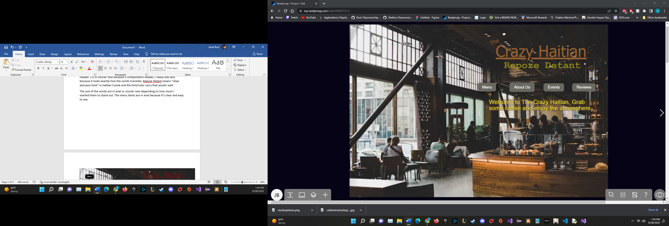

I chose to position the main banner at the top right so it’s easy to see and stands out nicely. I kept the rest of the text on the right side because it helped to keep everything in a visible and presentable form. I also wanted a simplistic design to be more inviting and so that it doesn’t feel overwhelming at first glance.

For the About Us page I added a font border and primarily used the yellow header color to stand out better against the background. I chose to use a picture of Nancy (my mom) and her grandmother because she was the main inspiration for my mother’s love of cooking. I chose a background image that supported a cozy feeling the go along with the family-oriented feeling of the page itself.

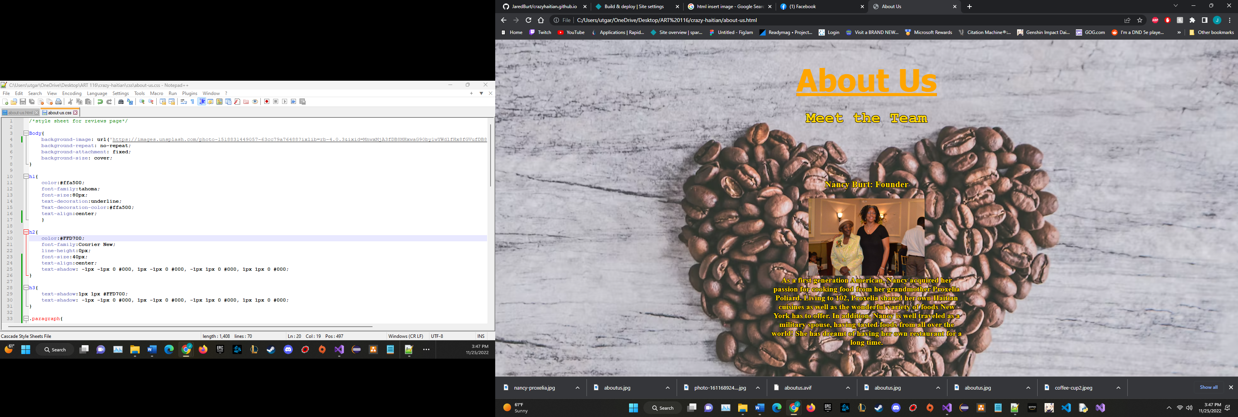

The Reviews page has been expanded into a Contact us page because it allows the users to ask questions and make suggestions. It’s set up to email the Crazy Haitians gmail directly. The colors have stayed consistent for the header and the font choice has stayed the same. I changed the font color to black so it would be more visible on this lighter brown background. The image here is simple and it occupies enough space to make the page feel a lot less empty. The proportions of the text and windows look better on the site itself.

